To do this, follow these steps:

1. Quit Word.
2. Click **Start**, click **Run**, type regedit in the **Open** box, and then click **OK**.
3. Locate and then click to select one of the following registry keys, depending on your version of Word:
   * For Microsoft Office Word 2007, locate and then click **HKEY_CURRENT_USER\Software\Microsoft\Office\12.0\Word\Options**
   * For Microsoft Office Word 2003, locate and then click **HKEY_CURRENT_USER\Software\Microsoft\Office\11.0\Word\Options**.
   * For Microsoft Word 2002, locate and then click **HKEY_CURRENT_USER\Software\Microsoft\Office\10.0\Word\Options**.
   * For Word 2000, locate and then click **HKEY_CURRENT_USER\Software\Microsoft\Office\9.0\Word\Options**.
   * For Word 97, locate and then click **HKEY_CURRENT_USER\Software\Microsoft\Office\8.0\Word\Options**
4. After you select the key that is specified in step 3, point to **New** on the **Edit** menu, and then click **String**.
5. Type ExportPictureWithMetafile, and then press ENTER.
6. Right-click **ExportPictureWithMetafile**, and then click **Modify**.
7. In the **Value data** box, type 0, and then click **OK**.
8. On the **File** menu, click **Exit** to quit Registry Editor.

Now, when you save a Word document that contains an EMF, a PNG, a GIF, or a JPEG graphic in a different format (for example, **Word 6.0/95 (*.doc)** or **Rich Text Format (*.rtf)**), Word does not retain two copies of the graphic and does not dramatically increase the file size of the document as compared to the Word version of the file.

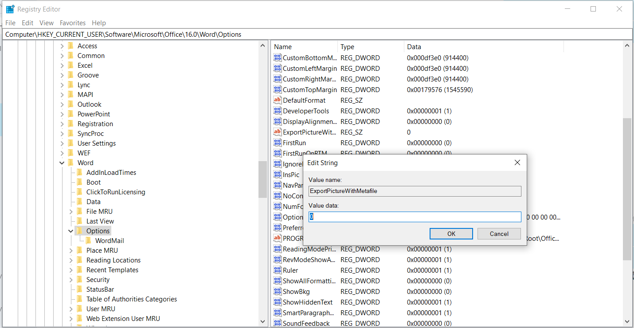

https://support.microsoft.com/en-ae/help/224663/document-file-size-increases-with-emf-png-gif-or-jpeg-graphics-in-word